Angel Levaomana

CS-340

2/21/2026

**Project Two – Grazioso Salvare Dashboard**

**Project Overview**

This project involved developing a MongoDB-powered dashboard application for Grazioso Salvare, an international search-and-rescue dog training company. The purpose of the dashboard is to allow users to filter and analyze animal shelter data to identify dogs suitable for specialized rescue training programs.

The dashboard provides interactive filtering options for Water Rescue, Mountain/Wilderness Rescue, and Disaster/Individual Tracking. Based on the selected filter, the data table updates dynamically. The application also includes a pie chart displaying breed distribution and a geolocation map that updates based on selected table rows.

The system was built using Python, MongoDB, and the Dash framework. The dashboard follows a model-view-controller (MVC) structure where MongoDB serves as the model, Dash components serve as the view, and callback functions serve as the controller.

**Tools and Technologies Used**

The following tools were used to complete this project:

**MongoDB:**  
MongoDB was used as the database management system. It stores the Austin Animal Center Outcomes dataset in a flexible document format. MongoDB was chosen because it integrates well with Python and allows dynamic querying using JSON-style filters, which is ideal for dashboard filtering functionality.

**Python:**  
Python was used to build the CRUD module and to connect to MongoDB. The CRUD_Python_Module.py file handles database operations such as retrieving filtered records.

**Dash Framework:**  
Dash was used to create the interactive web dashboard. Dash allows Python-based web development and supports interactive components such as radio buttons, data tables, charts, and maps.

**Plotly Express:**  
Plotly Express was used to generate the pie chart that dynamically updates based on the filtered dataset.

**Dash Leaflet:**  
Dash Leaflet was used to create the interactive geolocation map that displays the selected animal’s location.

These tools were chosen because they integrate seamlessly and allow dynamic interaction between the database and the user interface.

**Steps Taken to Complete the Project**

1. Developed a MongoDB database connection using a custom CRUD Python module.
2. Created a Dash dashboard layout, including the Grazioso Salvare logo and a unique identifier.
3. Implemented an interactive data table displaying animal shelter records.
4. Added radio button filters for Water Rescue, Mountain/Wilderness Rescue, Disaster/Individual Tracking, and Reset.
5. Built MongoDB queries that dynamically filter data based on the selected rescue type.
6. Connected the filtered data to a pie chart showing breed distribution.
7. Implemented a geolocation map that displays the selected animal’s location.
8. Tested all components to ensure the table, chart, and map update correctly when filters are applied.

**Challenges Encountered and Solutions**

During development, several challenges were encountered.

One challenge involved authentication errors when connecting to MongoDB. This was resolved by verifying the correct username and password used in the CRUD module and ensuring the connection string was properly configured.

Another challenge involved handling empty callbacks and indentation errors in Dash. These issues were resolved by ensuring each callback function contained valid return statements and was properly structured.

File path errors also occurred when loading the Grazioso Salvare logo. This was corrected by identifying the correct file directory and adjusting the image path accordingly.

Additionally, ensuring that all dashboard components (table, chart, and map) updated dynamically required careful callback configuration. This was resolved by properly linking inputs and outputs using Dash’s callback system.

Through testing and debugging, all issues were resolved, and the dashboard now functions correctly.

**Dashboard Functionality Screenshots**

1. **Reset (All) – Starting Dashboard**

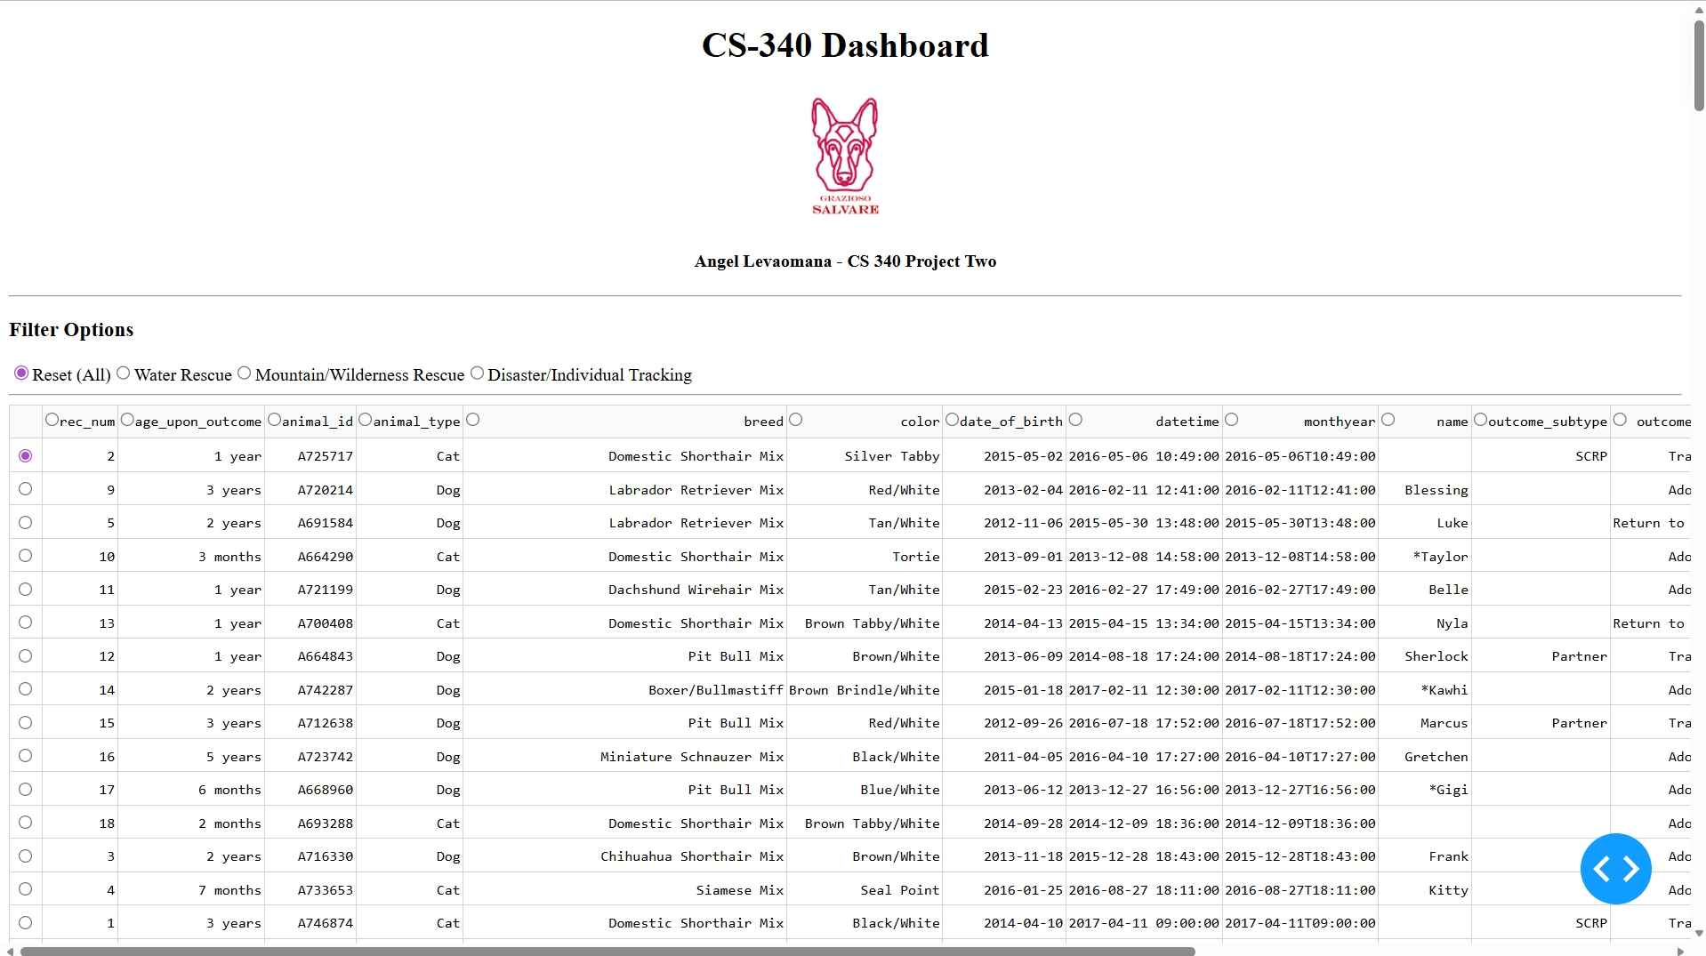

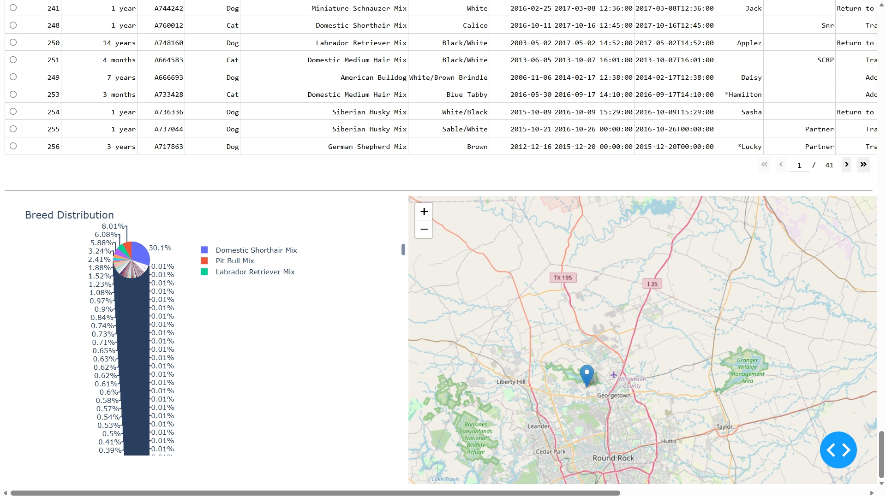

1. **Water Rescue Filter Applied**

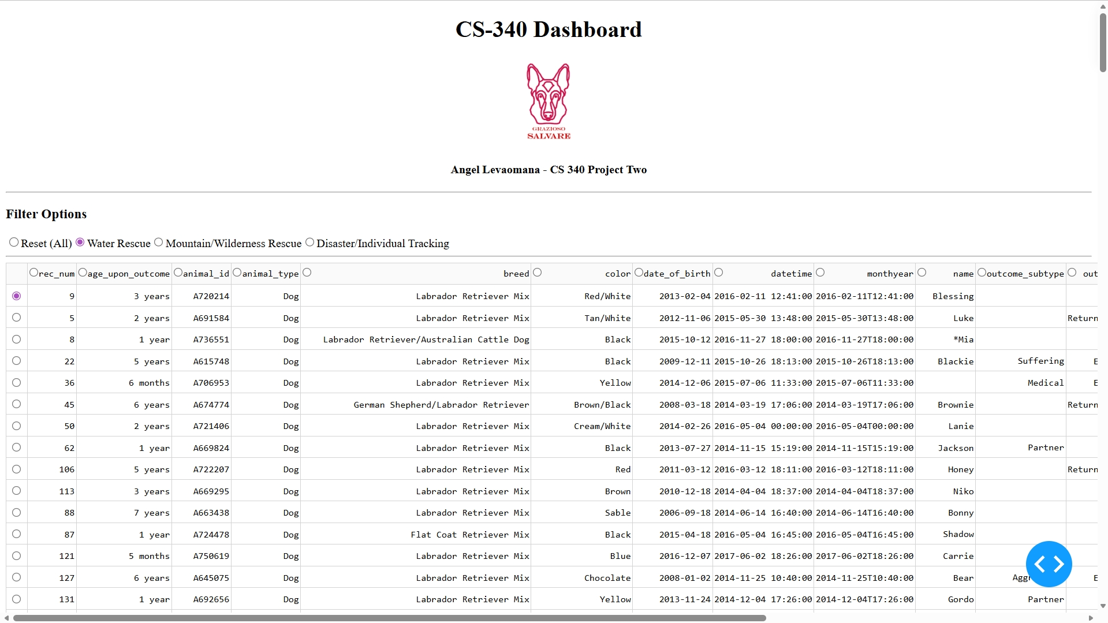

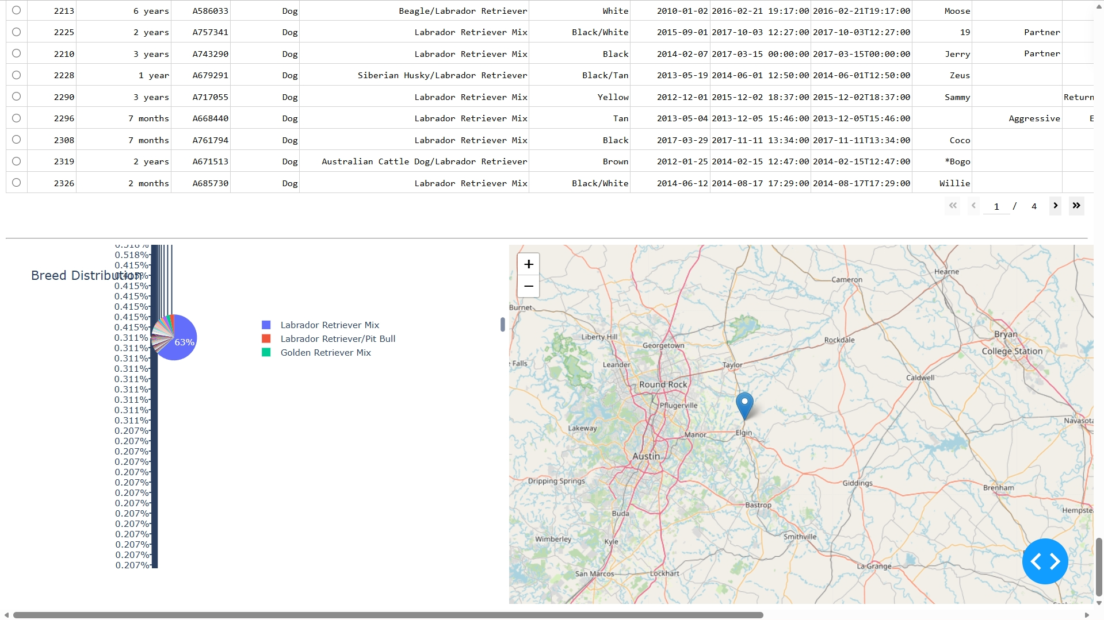

1. **Mountain/Wilderness Rescue Filter Applied**

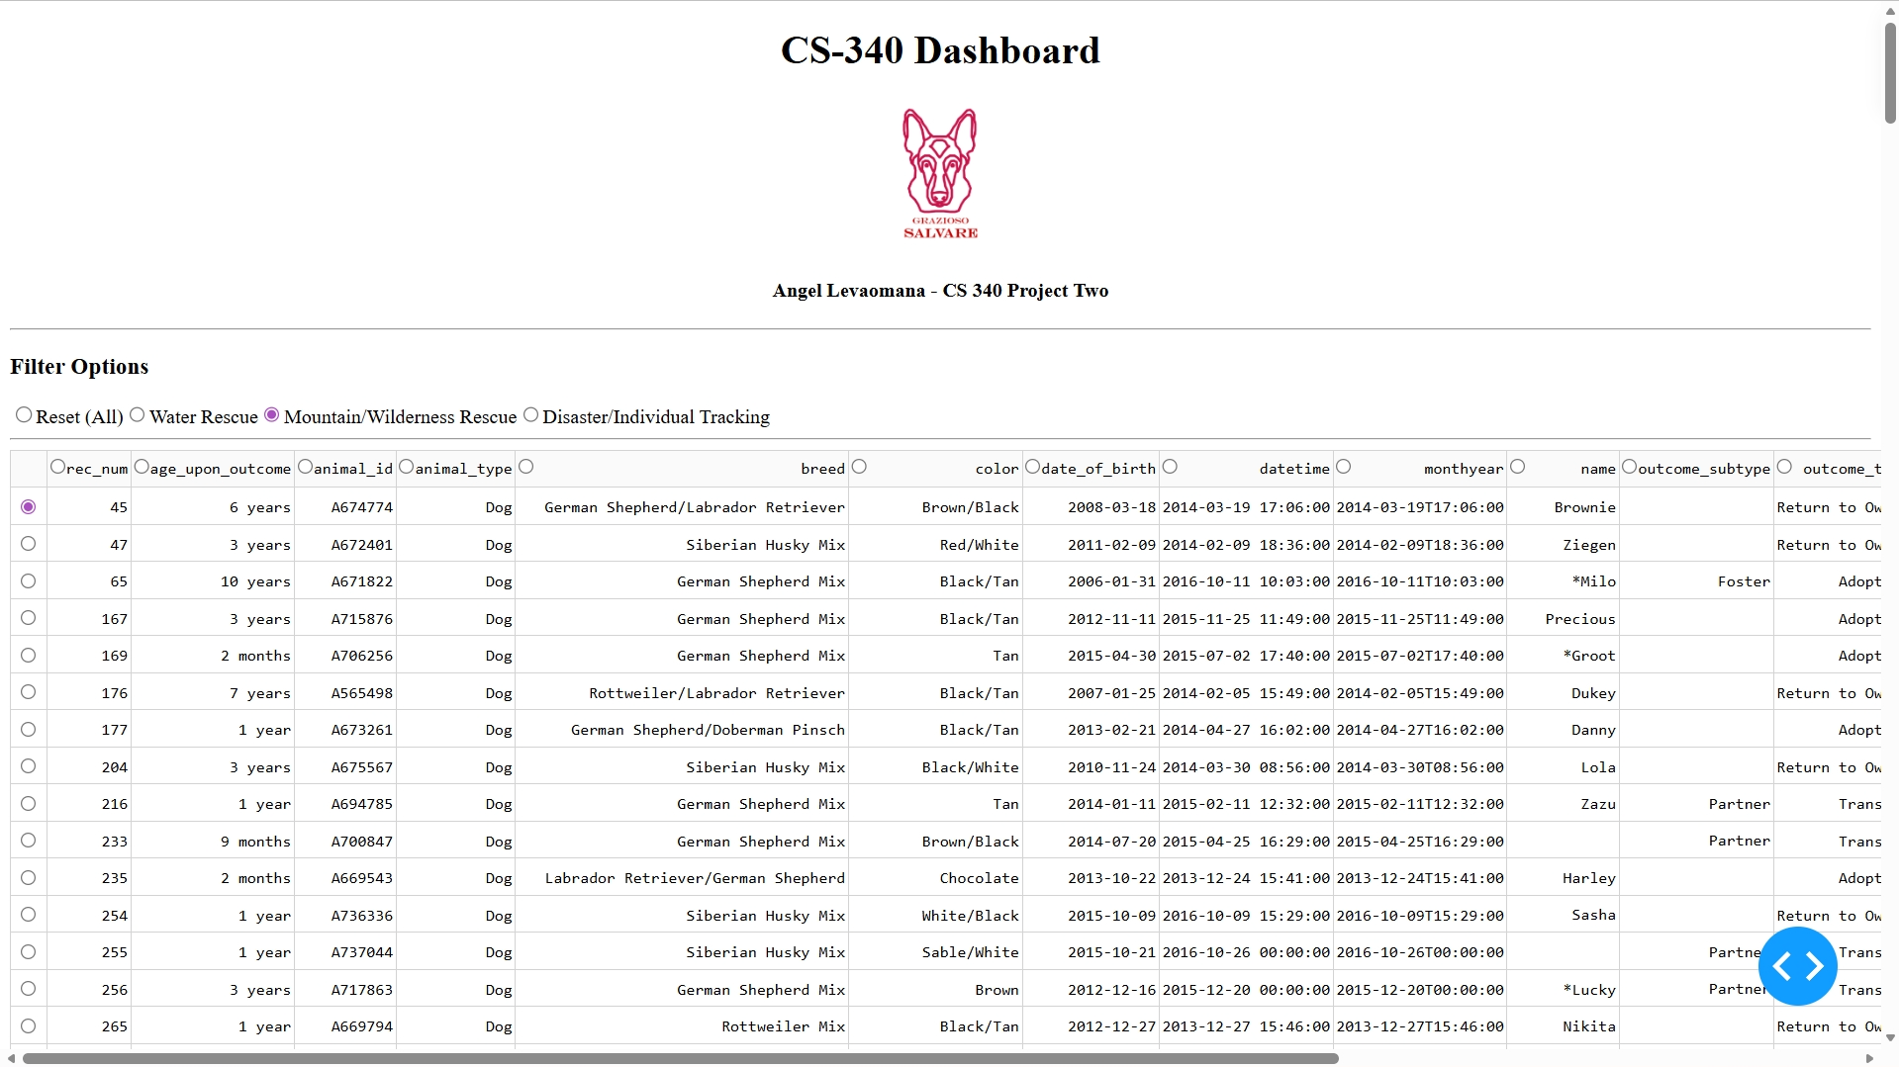

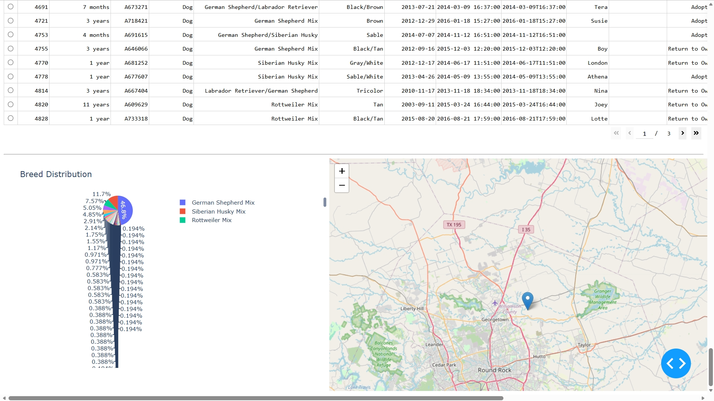

1. **Disaster/Individual Tracking Filter Applied**

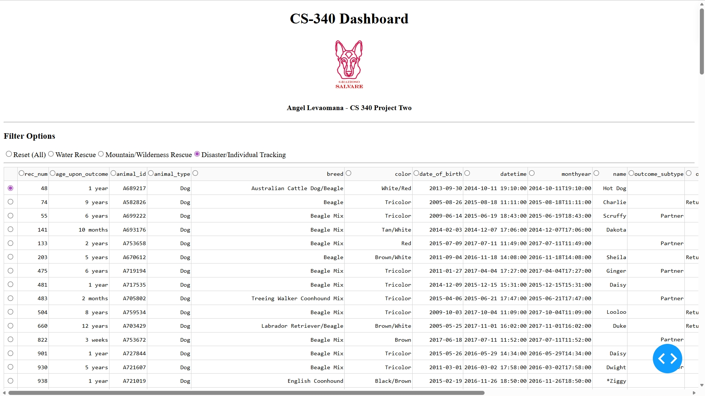

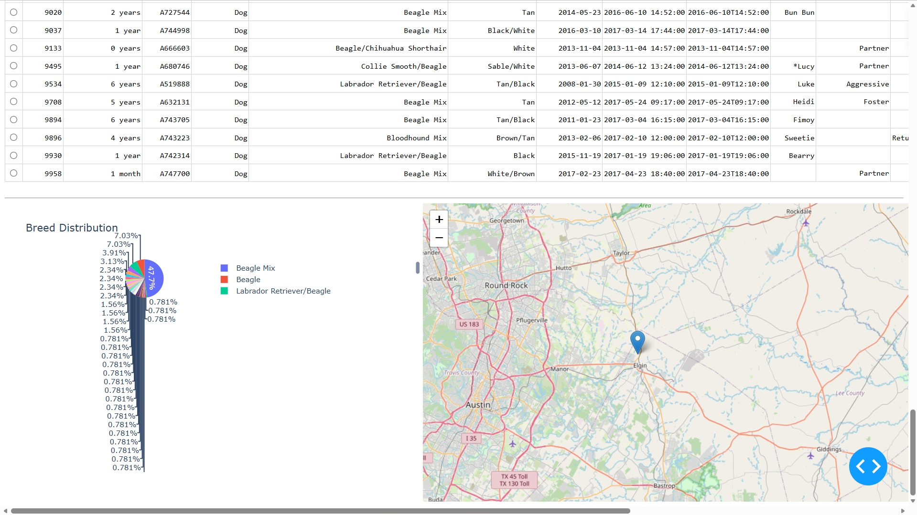

**Conclusion**

The completed dashboard successfully integrates MongoDB with a Python-based Dash application to provide interactive filtering and visualization of animal shelter data. The system allows users to quickly identify potential rescue candidates and analyze breed distribution and geographic location. All required components function dynamically and meet the project specifications.